Chapter 16, Problem 54.

The switch in Fig. 16.77 has been in position 1 for t < 0. At t =0, it is moved from position 1 to the top of the capacitor at t = 0. Please note that the switch is a make before break switch, it stays in contact with position 1 until it makes contact with the top of the capacitor and then breaks the contact at position 1. Determine v(t).

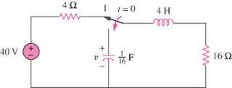

Figure 16.77
For Prob. 16.54.

